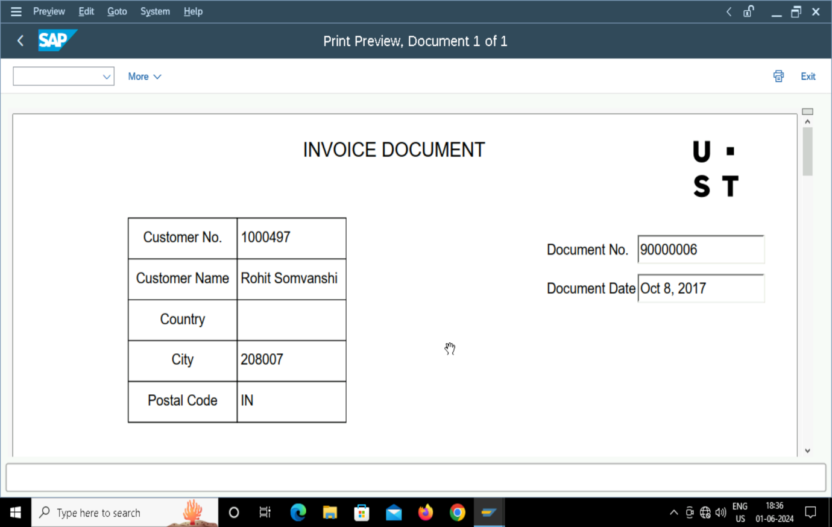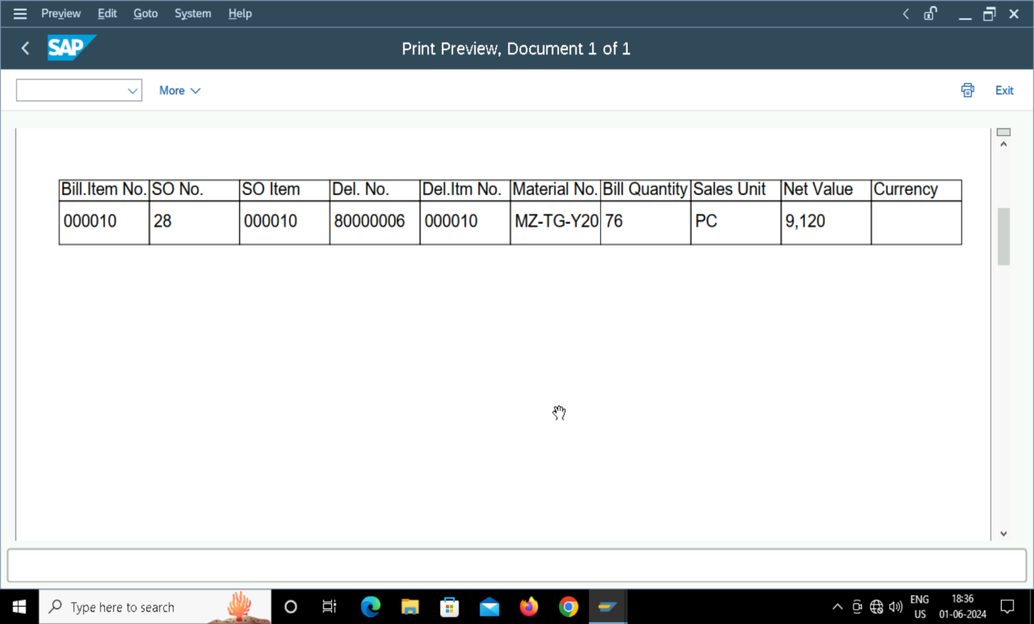

NAME: DHRUVI KHASIA

EMP ID: 280415

TR NO.:

GITHUB LINK: